**7.MULTI THREADING**

**SURYA K**

**20MCR076**

**AIM:**

To write the java code for multithreading.

**ALGORITHM:**

STEP1: Start the process.

STEP2: Create the class which are implemented in runnable interface.

STEP3: Here have define the main method in which will start the execution of thread.

STEP4: Create the new thread by instantiating a new class of thread.

STEP5: Here we use various stages of life cycle threads.

STEP6: Execute the process.

STEP7: Stop the process.

**CODING:**

**Main.java**

import java.util.*;

class MainThread

{

     public static void main(String[] args)

     {

          try

          {

               Fibonacci fib = new Fibonacci();

               fib.start();

          }

          catch (Exception ex)

          {

               ex.printStackTrace();

          }

     }

}

**Fibonacci.java**

import java.io.*;

class Fibonacci extends Thread

{

     public void run()

     {

          try

          {

               int a=0, b=1, c=0;

               BufferedReader br=new BufferedReader(new InputStreamReader(System.in));

               System.out.print("Enter the Limit for Fibonacci: ");

               int n = Integer.parseInt(br.readLine());

                             System.out.println("Fibonacci series: ");

               while (n>0)

               {

                    System.out.print(c+" ");

                    a=b;

                    b=c;

                    c=a+b;

                    n=n-1;

               }

          }

          catch (Exception ex)

          {

               ex.printStackTrace();

          }

     }

}

**OUTPUT:**

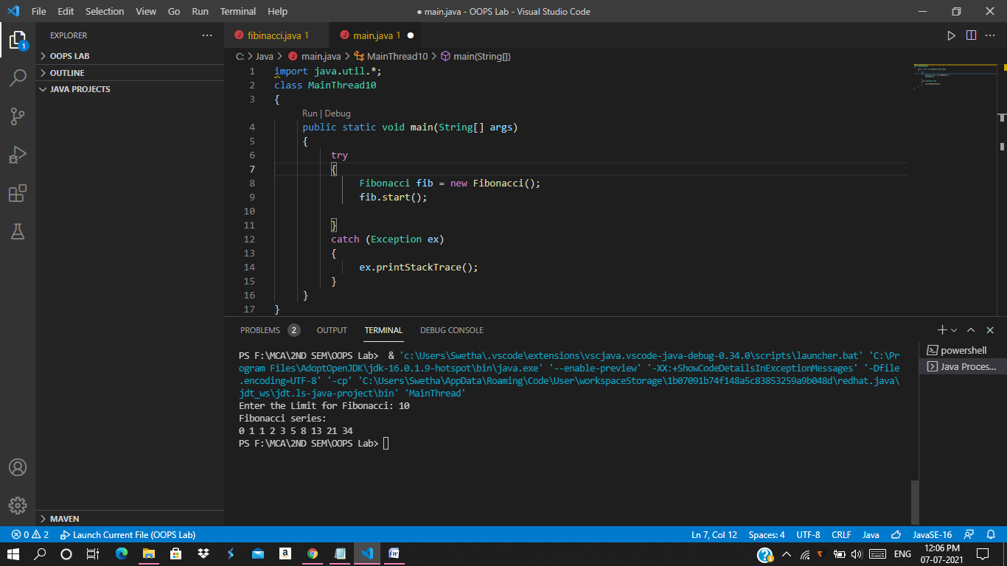

**RESULT:**

Thus the above code has been successfully executed.